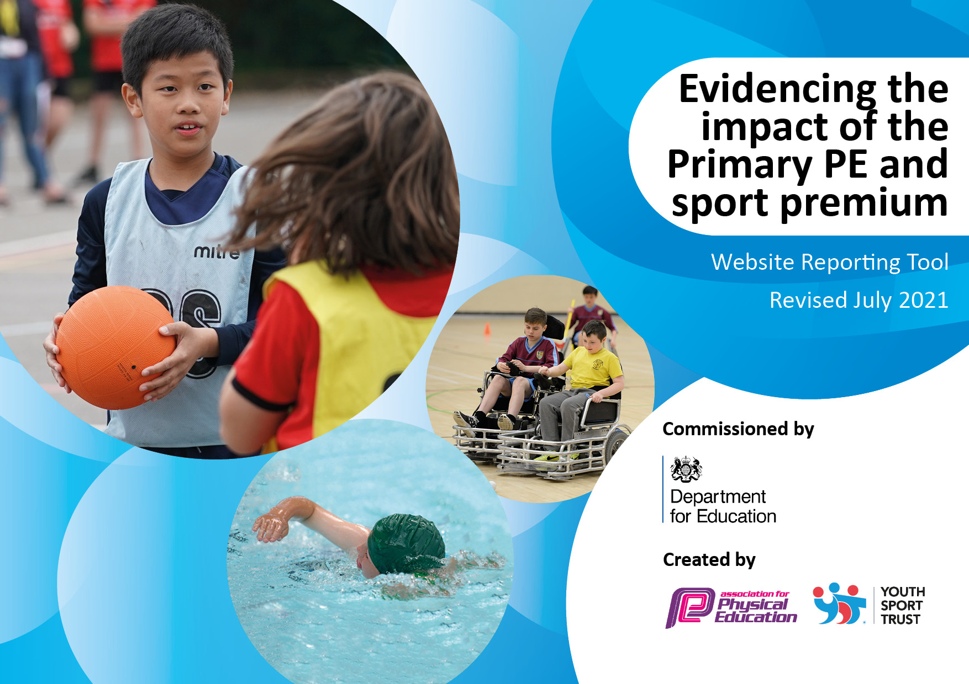
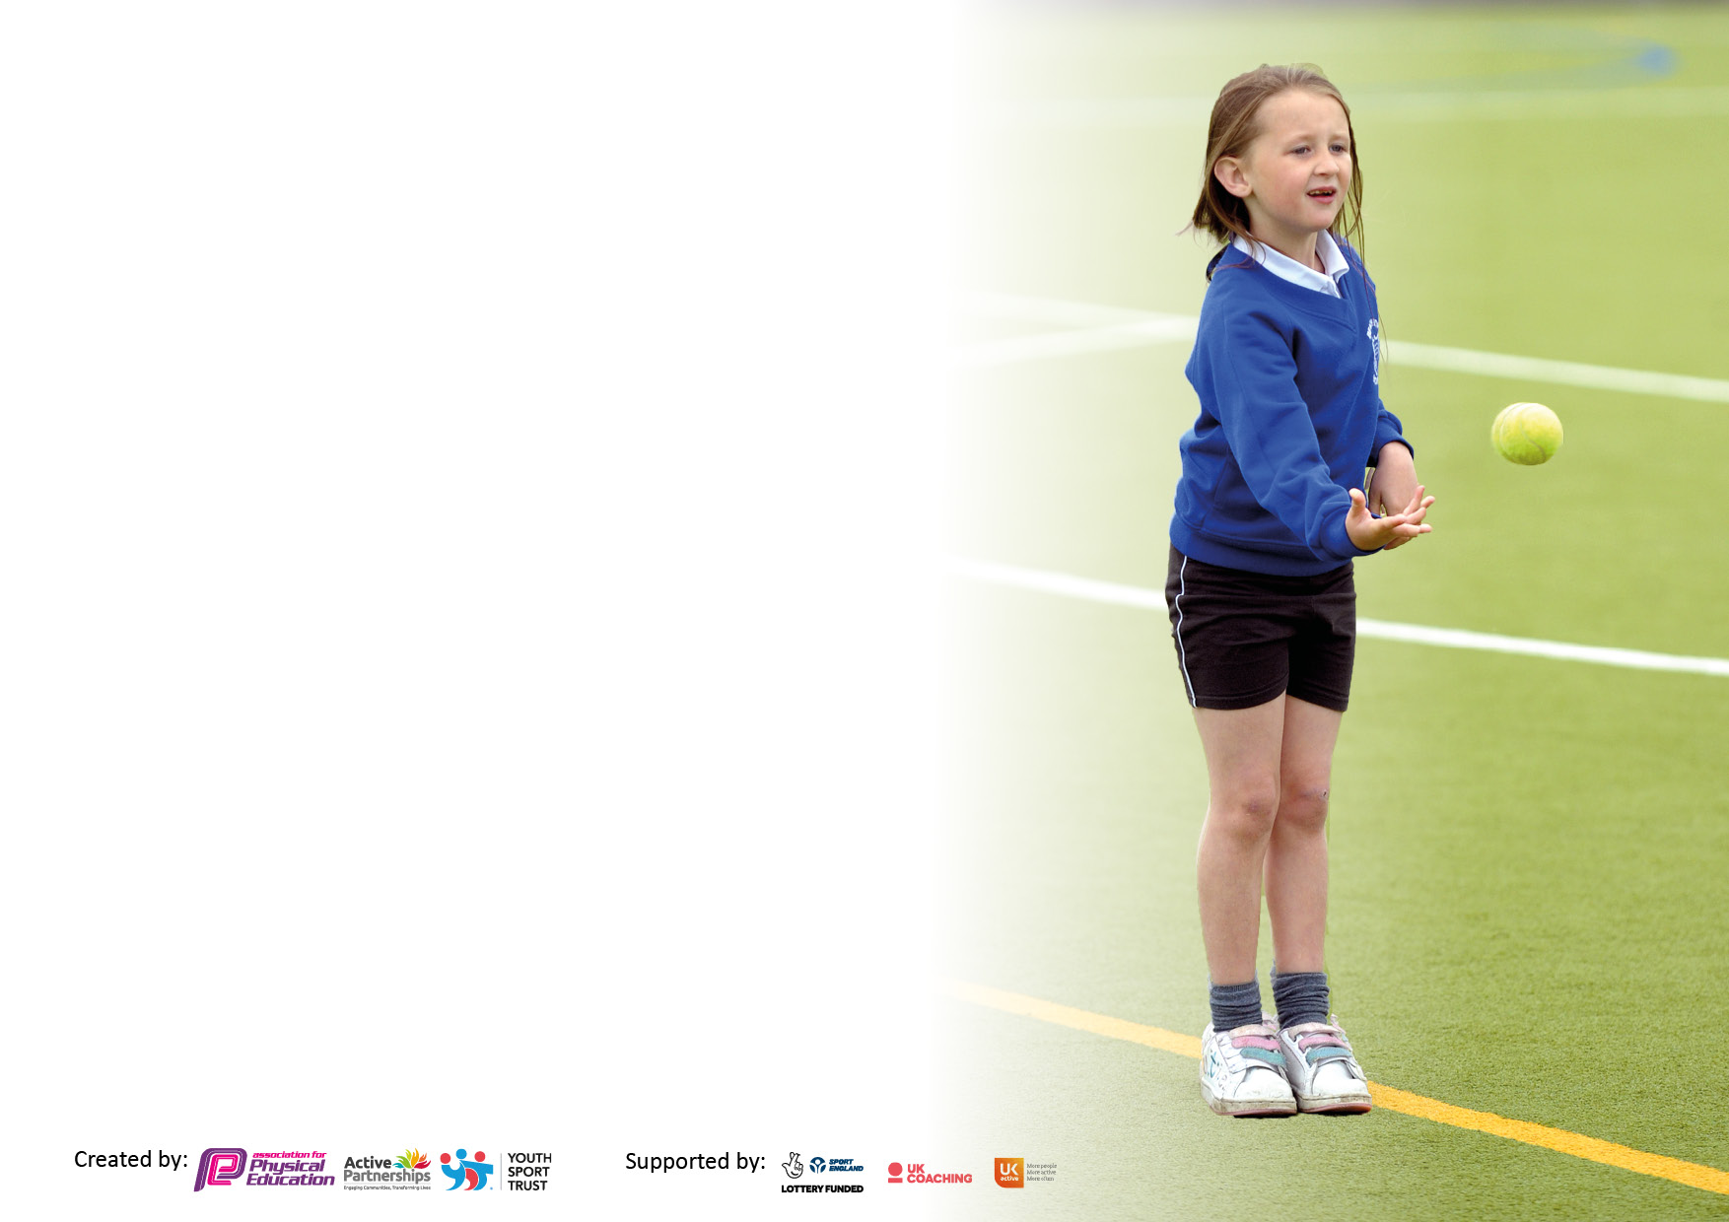

It is important that your grant is used effectively and based on school need. The Education Inspection Framework makes clear there will be a focus on ‘whether leaders and those responsible for governors all understand their respective roles and perform these in a way that enhances the effectiveness of the school’.

Under the Quality of Education Ofsted inspectors consider:
Intent - Curriculum design, coverage and appropriateness
Implementation - Curriculum delivery, Teaching (pedagogy) and Assessment
Impact - Attainment and progress

To assist schools with common transferable language this template has been developed to utilise the same three headings which should make your plans easily transferable between working documents.

Schools must use the funding to make additional and sustainable improvements to the quality of Physical Education, School Sport and Physical Activity (PESSPA) they offer. This means that you should use the Primary PE and sport premium to:

- Develop or add to the PESSPA activities that your school already offer
- Build capacity and capability within the school to ensure that improvements made now will benefit pupils joining the school in future years
- The Primary PE and sport premium should not be used to fund capital spend projects; the school’s budget should fund these.

Pleasevisitgov.ukfortherevisedDfEguidanceincludingthe5keyindicatorsacrosswhichschoolsshoulddemonstrate animprovement.Thisdocumentwillhelpyoutoreviewyourprovisionandtoreportyourspend.DfEencouragesschools to use this template as an effective way of meeting the reporting requirements of the Primary PE and sport premium.

We recommend you start by reflecting on the impact of current provision and reviewing the previous spend.

Schools are required to publish details of how they spend this funding, including any under-spend from 2019/2020, as well as on the impact it has on pupils’ PE and sport participation and attainment. All funding must be spent by 31st July 2022.

We recommend regularly updating the table and publishing it on your website throughout the year. This evidences your ongoing self-evaluation of how you are using the funding to secure maximum, sustainable impact. Final copy must be posted on your website by the end of the academic year and no later than the 31st July 2021. To see an example of how to complete the table please click HERE.
Created by: Supported by:

Details with regard to funding
Please complete the table below.

Total amount carried over from 2021/22 | £0
Total amount allocated for 2022/23 | £18,450
How much (if any) do you intend to carry over from this total fund into 2023/24 | £2715.23
Total amount allocated for 2022/23 | £ 18,450
Total amount of funding for 2022/23. To be spent and reported on by 31st July 2023. | £18,450
Swimming Data
Please report on your Swimming Data below.

Meeting national curriculum requirements for swimming and water safety.

N.B. Complete this section to your best ability. For example you might have practised safe self-rescue techniques on dry land which you can then transfer to the pool when school swimming restarts.
Due to exceptional circumstances priority should be given to ensuring that pupils can perform safe self rescue even if they do not fully meet the first two requirements of the NC programme of study
What percentage of your current Year 6 cohort swim competently, confidently and proficiently over a distance of at least 25 metres?  N.B. Even though your pupils may swim in another year please report on their attainment on leaving primary school at the end of the summer term 2021.  Please see note above | 100 %
What percentage of your current Year 6 cohort use a range of strokes effectively [for example, front crawl, backstroke and breaststroke]?  Please see note above | 91%
What percentage of your current Year 6 cohort perform safe self-rescue in different water-based situations? | 93%
Schools can choose to use the Primary PE and sport premium to provide additional provision for swimming but this must be for activity over and above the national curriculum requirements. Have you used it in this way? | Yes/No

Action Plan and Budget Tracking
Capture your intended annual spend against the 5 key indicators. Clarify the success criteria and evidence of impact that you intend to measure to evaluate for pupils today and for the future.

Academic Year: 2022/23 | Total fund allocated: | Date Updated:
Key indicator 1: The engagement of all pupils in regular physical activity – Chief Medical Officers guidelines recommend that primary school pupils undertake at least 30 minutes of physical activity a day in school |  |  |  | Percentage of total allocation:
5.46%
£1007
Intent | Implementation |  | Impact
Your school focus should be clear what you want the pupils to know and be able to do and about  what they need to learn and to  consolidate through practice: | Make sure your actions to achieve are linked to your intentions: | Funding allocated: | Evidence of impact: what do pupils now know and what can they now do? What has changed? | Sustainability and suggested next steps:
To provide swimming sessions for all key stage 1 and SEND children to encourage an interest in swimming, build water confidence and increase physical exercise. | All children in Key stage 1 and 2 will take part in swimming lessons provided by Pools for schools – Elite Swimming. | £418  £190 | Children have been awarded bronze, silver or gold swimming certificates showing swimming progress across the school.  The children who were reluctant swimmers gained confidence across all year groups and the catch up swimmers achieved required standard. | Fitting of socket and outdoor tap means that the pool can be booked each year.
To raise the profile of the benefits of health across the school. | Freddie Fit Workshop for whole school to develop fitness, strength, coordination, self-esteem.  The aim is to engage as many children as possible in a different, fun activity. | £399 | Children and staff enjoyed the benefit of physical exercise and have the children responded brilliantly to the different workshops. They both promoted good health and well-being in a fun and inclusive way – engaging children who are not always keen to participate in sports. | To raise the profile of the benefits of health across the school in line with our main school priority
Key indicator 2: The profile of PESSPA being raised across the school as a tool for whole school improvement |  |  |  | Percentage of total allocation:
6.5%
£1200
Intent | Implementation |  | Impact
Your school focus should be clear what you want the pupils to know and be able to do and about  what they need to learn and to  consolidate through practice: | Make sure your actions to achieve are linked to your intentions: | Funding allocated: | Evidence of impact: what do pupils now know and what can they now do? What has changed? | Sustainability and suggested next steps:
Forest School teacher to be trained online accredited Level 3 qualification plus face to face training |  | £1200 | Staff member allocated and has researched the possible courses to apply for. This is to run over to next year.

Key indicator 3: Increased confidence, knowledge and skills of all staff in teaching PE and sport |  |  |  | Percentage of total allocation:
10.5%
£1931.27
Intent | Implementation |  | Impact
Your school focus should be clear | Make sure your actions to | Funding | Evidence of impact: what do | Sustainability and suggested
what you want the pupils to know | achieve are linked to your | allocated: | pupils now know and what | next steps:
and be able to do and about | intentions: |  | can they now do? What has
what they need to learn and to |  |  | changed?
consolidate through practice:
Staff to develop their confidence in teaching PE using a new resource to ensure children gain knowledge, skills and competence in P.E. progressively, whilst participating in a broad and balanced range of activities | All staff to use ‘GetSet4PE’ to plan and deliver P.E. lessons | Get Set for PE £495 primary package | Children have benefited from well sequenced and progressive PE curriculum. Subject leader saw in observations, how the progression is evident across key stages. A wider variety of activities have been provided to children. | Subject leader to monitor implementation and renew subscription for 2023 to 2024
Resources for improved PE lessons to allow the delivery of Get Set 4 PE | Specialist equipment purchased for the delivery of high quality PE sessions. | £1436.27 | Children have benefited from the well equip PE sessions allowing then to gain skills with the correct and effective resources.  Resources are now complete to allow full delivery of Get Set 4 PE scheme. | Subject leader to regularly audit resources for PE sessions.
Key indicator 4: Broader experience of a range of sports and activities offered to all pupils |  |  |  | Percentage of total allocation:
43.66%
£8055.50
Intent | Implementation |  | Impact
Your school focus should be clear | Make sure your actions to | Funding | Evidence of impact: what do | Sustainability and suggested
what you want the pupils to know | achieve are linked to your | allocated: | pupils now know and what | next steps:
To encourage more pupils to take up sport and physical activities | Work with PE subject lead to plan and deliver an exciting, inclusive sports day including all resources and management of the day. Costs include cover for PE lead, coaches for the day and release time. | £685 | Whole school plus feeder nursery took part in sports day, event was successful and enjoyed by parents and children. | Review coaches delivery of sports day and gather feedback from parents
To encourage a greater variety of intra house sports competitions to raise the profile of house and team work | ASM to work with a different class every week to deliver 2 hour intra house mini competitions (in addition to core PE lessons) | £2730 | Children have been encouraged to work as a house team and valued this team work, they are recognising their team more and that working together as a team raises self-esteem and the sense of belonging. | To continue year on year
To providing targeted activities or support to involve and encourage the least active children encouraging active play during break times and lunchtimes | ASM to lead a ‘Sports Leaders’ course for identified children to give them a leadership role to encourage them to design and lead activities that will appeal and encourage other less active or reluctant children. Costs include cover for PE lead and release time for teachers to support the course | Sports Leaders Training - £225  Sports leaders and caps and whistles £90.50 | Children have established themselves as play leaders and take their role seriously. More children involved in playtimes and leaders have increased personal development. | Run play leader scheme in 2023-2024 and recruit new pupils
To encourage a variety of lunch time sports with ASM coaches and encourage participation. | ASM to run a Wednesday lunch club to target those children who may not always participate and provide more sports than football. | £1365 | Children have been encouraged to partake in other sports and physical activity other than football at playtimes. | Continue next year
To provide support for pupils to achieve a healthy mind | Visyon counselling bought in service for 3 terms | £2960 | Positive case studies | Renewed contract for 2022-2023 to ensure continuity and provision for further pupils
To raise the profile of girls football to promote health and inclusivity. | Female coaches from First 11 coaching the girls club with intention to create a girls team. | N/A | More inclusive opportunities to involve wider groups of pupils. School council voted to continue with the club.  The girl’s football session is extremely popular and has allowed the formation of a squad. The squad have played friendlies against other schools and then entered a tournament against other local schools where they reached the final. Positive parent feedback and clear confidence building seem across the girl’s team.  This led to further exploration of encouraging more girls participation in sports and led to the formation of a highly popular mixed key stage 2 netball club.

Key indicator 5: Increased participation in competitive sport |  |  |  | Percentage of total allocation:
19.2%
£3541
Intent | Implementation |  | Impact
Your school focus should be clear | Make sure your actions to | Funding | Evidence of impact: what do | Sustainability and suggested
what you want the pupils to know | achieve are linked to your | allocated: | pupils now know and what | next steps:
and be able to do and about | intentions: |  | can they now do? What has
what they need to learn and to |  |  | changed?:
consolidate through practice:
To continue membership of Stockport SSP and MSSP Schools Sports | Engage as many children as possible in the sports experiences provided by SSP and MSSP | £550 (MSSP)  £40 (SSSP) | Partnership provided quality inter school sports competitions Lower Park took part in the athletics competition. | To continue for local sharing of best practice.
All children in KS2 to have the opportunity to represent the school at a sporting event. | MSSP to enable all children to have the opportunity to represent the school.  Use the new grading criteria from the MSSP to aid the selection process. | £1751 | Children took part in a variety of ‘Inspire, Aspire and Celebrate’ events, graded according to ability expected and whether it is a new sport to them. These are organised and graded by MSSP school games and contributed to the school games award which has been submitted by the PE coordinator. | Continue to attend as many events as possible throughout the year, keeping a register of the children attending.
Provide high class coaching to the football to enable them to have greater participation in a wider range of competitions | FA level 2 coach Tony Timmons to work with the football squad for 60 mins every week | £1200 | This has been successful and led to the squad reaching the semi-finals.  This was extended to allow both Year 5 and 6 children to take part in the club to encourage greater participation and a clear succession for the football squad. | Continue with this throughout the year.

Signed off by
Head Teacher: | Amelia Lomas
Date: | 9.12.22
Subject Leader: | Emma Cunha
Date: | 29.11.22
Governor: | Richard Simkin
Date: | 9.12.22
Impact reviewed | 27.6.23

